**LOWER SKILLS CAREER DEVELOPMENT EVENT RULES AND REGULATIONS**

**2024-2025 School Year Please Read These Rules Carefully!!**

**General**

1. All advisors present shall serve as judges in some capacity at the West TN Skills CDE. There will be at least two judges per activity/skill. As an advisor, it is your job to communicate with the skills committee what you are comfortable or not comfortable judging the day of the contest.

1. Chairman or Chairmen will draw for lower skills in the designated area and students will follow the instructions of the chairman or will be disqualified.

1. The skills will not be announced until students have reached designated area of skill in the shop or classroom.

1. No alternates for the Lower Skills CDE effective immediately.

1. All variances in stud assembly, plumbing, and wiring will be determined by random draw by the skill judges on-site on the day of the contest. This will not be pre-determined before arriving at Haywood County High School.

1. Teachers with teams are to remain out of the contest area while contestants are participating in the CDE except the host advisor. During the judging, teachers and contestants shall clear the area. Violators shall be disqualified in this skill.

1. Judges shall arrive at CDE site at 1:00pm (30 minutes early) to survey working facilities in advance of the CDE and to arrange adequate working space. The CDE will begin promptly at 1:30pm. Advisors shall register all contestants one week prior to the CDE on [http://westtn.ffanow.org a](http://westtn.ffanow.org/)nd then check team members in, making any corrections, the day of the CDE. There will be a meeting of judges with CDE chairman and advisors to review the rules of each skill prior to the CDE.

1. Judges shall eliminate all ties before reporting final placing. Chairman of the judges is responsible for breaking team ties as follows: “In breaking ties in the skills CDE, the team that finished with the most firsts shall win; this procedure shall continue until a winner is decided. If teams remain tied, the team that places highest in welding in the upper division and the team that places highest in stud assembly shall be the winner.

1. No results shall be announced or posted until all results have been turned in to the chairman of the judges.

1. Judges shall be available to discuss placing after individual skill results have been turned in to the chairman of judges.

1. The West Tennessee CDE shall be held at Haywood High School.

1. Prior to beginning the CDE, the chairman of the judges shall conduct a drawing to determine which skill each contestant will compete in. Contestants from each school will be listed with consecutive numbers beginning with number one. The four skills will be written on identical slips of paper and folded. With land leveling and land measuring the skill shall be written on two slips of paper. The chairman of the judges shall draw one skill and all contestants with the number one shall perform that skill. The skill will not be announced until that group is dismissed to the skill area. A second skill will be drawn and all contestants with the number two shall perform that skill. The procedure will continue until all skills have been drawn. In the case of land leveling or land measuring where two members will compete, the team will be those numbers drawn at random as is with the rest of the skill areas. These contestants may or may not be consecutive on the list of alphabetically listed students. The same procedure shall be used for both upper and lower division.

1. To be eligible to compete in lower skills, the FFA member must be a ninth grader and a freshman in high school.
2. No reference material including notes, rules, tables, or programmable calculators shall be available to the contestants at the site of the CDE unless specified in individual skill rules. If a student is caught using a cell phone during a CDE, he/she will be disqualified from the event.

1. **Lower Skills for 2022-23 and beyond** 
   1. **Plumbing (1 person)**
   2. **Small Engine Identification (1 person)**
   3. **Electrical Wiring (1 person)**
   4. **Stud Assembly (1 person)**

1. All judges will discuss with the Chairman of the judges how their event will be conducted, before starting the skill event. The judge should be notified if student is missing materials to complete skill and provide item is available.

1. If a team does not have a student representative in a skill area, or if the student in the skill area gets disqualified from the event, the team score for the event will be last place minus one placing. Ex: If a team does not have a student for electrical wiring and 5 teams are registered for the CDE, the team score for that event will be 6th (5th place – one placing).

1. Haywood High School will be responsible for supplying small engine parts for the lower division small engine ID.
2. All judges in all skill areas will check all supplies before the student begins.

**LOWER SKILLS CDE RULES**

**2022-Present**

**(Limited to ninth grade only)**

**STUD ASSEMBLY**

1. Supplies needed: One (1) 2 by 4 forty-eight inches (4 feet) long, two 16 penny common nails. Contestant will ***not*** be penalized for bringing extra nails.
2. Equipment needed: Hand-held portable power saw, sawhorse(s), clamp to secure wood when sawing, hammer, square, tape measure, pencil, and safety glasses.
3. The judge will mark each end of the 2 x 4 with a marking pen before the contest begins. Contestants must have sawed off both ends of the 2 x 4 when turning in completed project.
4. Contestant will construct a T-shaped design with both boards being identical in length. Judge will give measurements prior to the beginning of the contest. Measurement shall not be in smaller increments than 1/8 inch and shall be between 20 and 23 ½ inches. These will assigned by random draw
5. Only **four** cuts of the 2 x 4 are allowed.
6. The two boards shall be nailed together using two 16-penny nails. The 16 penny nails shall be nailed ¾” from the edge of the 2 x 4. There **will not** be any toe-nailing on this project.
7. The leg of the T-shaped project shall be nailed in the center of the cross member.
8. The time limit shall be 30 minutes.
9. A non-carpentry calculator may be used to determine the center distance of the board.
10. Safety glasses must be worn by the contestant.
11. Points values can be a negative value on the scoring rubric.
12. All Boards completed according to the rules will be placed above those that are not.



A



Length of A

shall be from

20

to 23 ½”

in length.



A



16

d nails ¾ from edge

Score Sheet

|  |  |  |  |  |  |  |  |  |  |  |  |  |  |
| --- | --- | --- | --- | --- | --- | --- | --- | --- | --- | --- | --- | --- | --- |
| Maximum  Points |  | 1 | 2 | 3 | 4 | 5 | 6 | 7 | 8 | 9 | 10 | 11 | 12 |
| 30 | Length: 2 points deducted per 1/16” error. |  |  |  |  |  |  |  |  |  |  |  |  |
| 14 | Square: 2 points deducted per 1/16” error. |  |  |  |  |  |  |  |  |  |  |  |  |
| 14 | Centered: 2 points deducted per 1/16” off center. |  |  |  |  |  |  |  |  |  |  |  |  |
| 4 | Nails: 2 points deducted per  1/16” off correct location |  |  |  |  |  |  |  |  |  |  |  |  |
| 10 | Nailing: 1 point deducted for each wood scar caused by nailing. Over all appearance |  |  |  |  |  |  |  |  |  |  |  |  |
| 18 | Following procedure by cutting both marked ends |  |  |  |  |  |  |  |  |  |  |  |  |
| 10 | Safety Glasses        Total Points |  |  |  |  |  |  |  |  |  |  |  |  |

1

**ELECTRIC WIRING (freshman member only)**

1. The contestant will wire a light operated by a switch. The light will be a plastic or porcelain keyless light fixture attached to a 4-inch octagon outlet box 1 1/2 to 2 inches deep. The switch will be in a surface mount outlet box.
2. The source wire will enter through the octagon box. Number 14-2 WG romex or equivalent wire will be used. No fixture wire will be used in the octagon box connecting to the light fixture.
3. The boxes will be attached to a two by four two foot long unpainted and unstained board. Failure to follow the preceding sentence will result in the contestant placing being lowered one place. The boxes will be mounted to the board prior to the CDE using four wood screws.
4. The ground wires in the octagon box shall be twisted together and connected with a crimp-type connector or a green grounding wire nut with one ground wire connected to a machine-threaded screw in the bottom of the box. The ground wire in the switch shall be connected to a machine threaded screw in the bottom of the box and to the switch.
5. All boxes shall be above the surface of the board.
6. Six inches to eight inches of free romex and insulated wire shall be left in the box after connections are made measured from point of entry.
7. All romex must be clamped securely in the boxes.
8. When complete the switch shall be fastened in the box and covered with a metal cover plate.
9. The light fixture shall be mounted to the octagon box when completed.
10. The switch wires are to be connected by the eyelets. Ground wire in receptacle boxes should be secured in a horseshoe or half moon configuration.
11. The contestant will not be penalized for bringing extra supplies.
12. The white wire leading to the switch may or may not be identified with black tape.
13. Time limit will be one hour.
14. The contestant must wear safety glasses. Failure to do so will result in lowering contestant one place.
15. ¼” to ½” romex is required inside the box, as measured from the connector to the end of the romex.
16. The source wire will not be altered, cut, or stripped.
17. Wires can be connected to either terminal on the switch.
18. All wiring boards will be tested with an ohm meter for continuity.

**The following materials are necessary to complete the job:**

2x4 two feet long One surface-mount outlet box

5 feet unmarked 14-2 WG wire **only** One 4” octagon outlet box 1 1/2 to 2” deep

One single-pole toggle switch with ground One surface-mount metal switch cover

One keyless light fixture Three romex connectors

Eight wood screws Two grounding screws

Crimp-type or screw-on type grounding connector

**SCORE CARD**

|  |  |
| --- | --- |
| 1. Tightness of connections | 25 points |
| 2. Insulation (covering all wires) | 25 points |
| 3. Freedom from injury to wires in stripping, insulation, or twisting | 25 points |
| 4. Adequate wire in boxes | 10 points |
| 5. General neatness | 15 points |

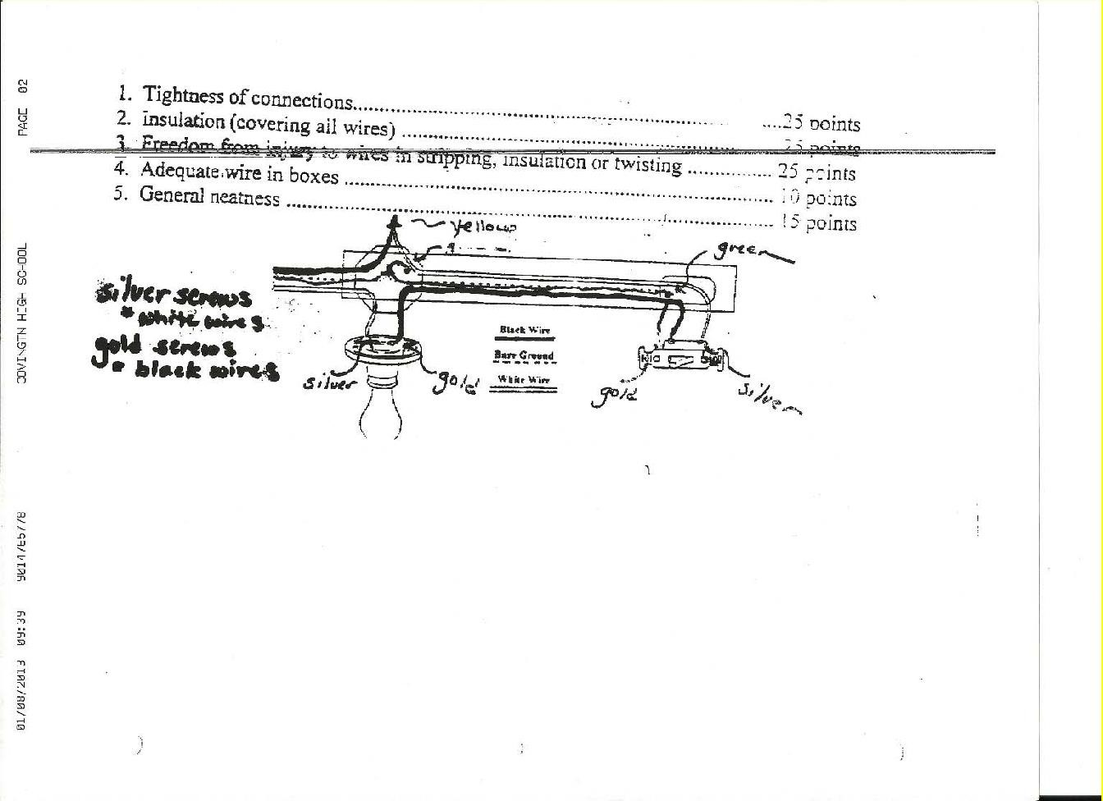

**PLUMBING**

**GENERAL INFORMATION/DIRECTIONS**: Students will be required to build a pvc pipe system resembling the example below. **Measurements shown are just for example only. The judges will determine contest measurements the day of the contest as well as location of the adapter leg.** Project will be judged off of correct measurements, pipe, primer, glue, fittings, and ability to hold water. Students must complete all cutting with non-electric cutting tools (ex. Pipe cutter, hacksaw). All pieces will be hooked to a water hose to test water holding ability. Safety glasses must be worn at all times

**Materials to Bring**

* 3 foot regular 3/4” schedule 40 pvc pipe. (Do not bring cpvc pipe)
* Cutting tool • 1 - ¾” pvc tee
* 2 - ¾” pvc caps (preferably flat to make judging easier, but rounded caps can be used)
* 1 – ¾” pvc female adapter
* PVC rated glue
* PVC Purple Primer
* Non- Electric Measuring Tool (ex. Tape Measure, foldable ruler)

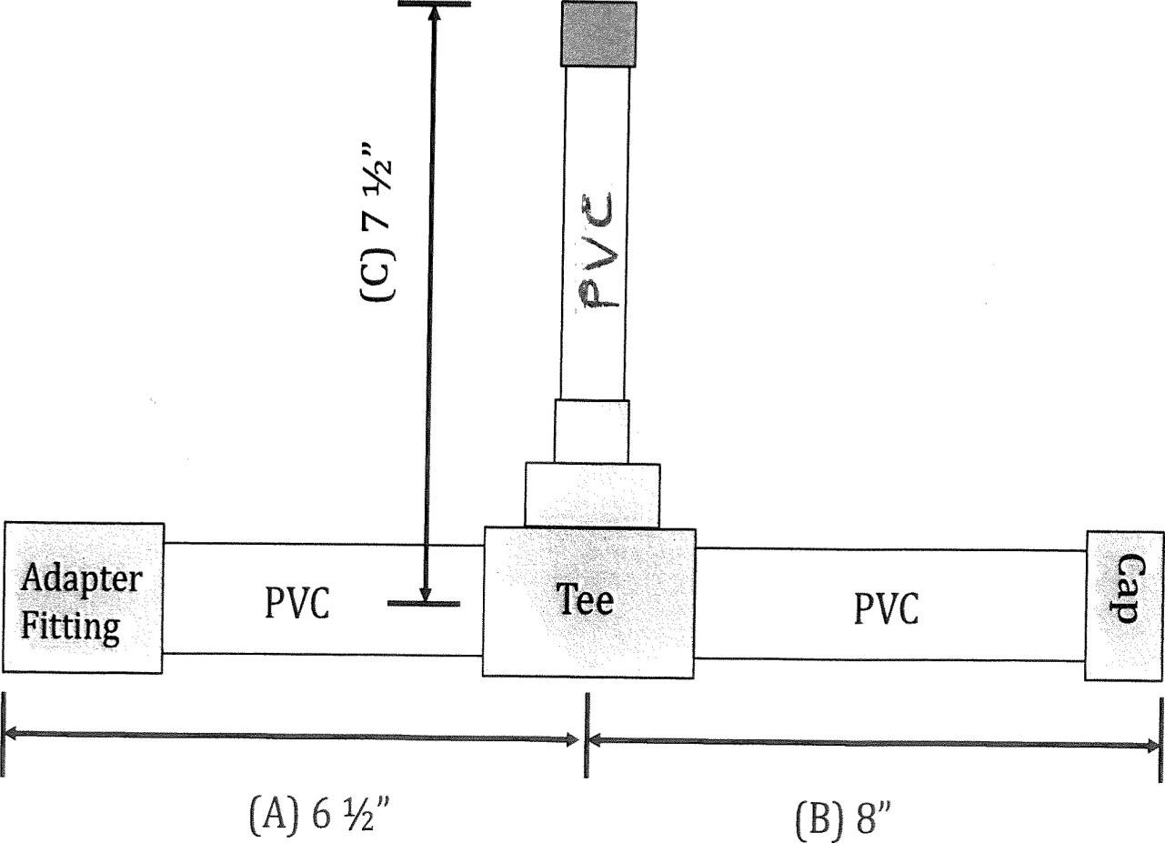

**Total Activity Points: 100 Measurements**

4o points maximum: Minus 2 per 1/16 inch

Purple primer visibility (Purple primer must be visible completely around each joint) 30 points maximum: Minus 5 points per joint.

Correct placement of Adapter: 20 points

Uniformity of Work (Ex. Excess glue, primer): 10 points

If Plumbing project that doesn’t hold pressure for set amount of time.

Disqualifying factors: Any pipe other than PVC, Glue not rated for PVC, and typical other disqualifying factors.

**SMALL ENGINE PARTS IDENTIFICATION**

1. Twenty-five parts shall be identified from the list on page 30. In case of a tie, the contestant completing in the shortest length of time shall be given the highest rank.
2. The judge shall bring a stopwatch to time each contestant
3. No contestant shall be allowed more than 10 minutes to identify parts.
4. Students will be able to view the set-up of the room with numbers in place prior to the beginning of the event (no parts on numbers at this time).
5. The contestant will be seated at the first Small Engine part with his/her back to the table when time begins. Time will be stopped when the paper is handed to the judge who will be standing beside the last Small Engine part.
6. The host advisor shall furnish mimeographed check forms for small engine parts identification, parts listed alphabetically; a sample copy is attached.
7. Parts shall be displayed on numbered typing paper.
8. Parts displayed must be numbered consecutively.
9. Contestants will be allowed to view parts prior to numbering for contest. Judge will identify parts if asked by contestant during the time for viewing. All parts on list should be on display if at all possible.
10. Instructions to judges: A perfect score is 52 (one for each blank). All blanks should be correctly filled in or left blank according to the judge’s key.
11. West Tennessee CDE parts shall be furnished by Haywood High School.



**SMALL ENGINE IDENTIFICATION**

Contestant Name Time Score

Air Cleaner Fuel Tank

Air Cleaner Foam Filter Fuel Tank Cap

Air Vane Link Governor Blade

Blower Housing Governor Spring

Brake and Stop Switch Grommet

Breather Assembly Intake Manifold

Breather Gasket Intake Manifold O Ring Seal

Breather Tube Magneto Armature

Camshaft Muffler

Carburetor Oil Drain Plug

Carburetor Diaphragm Oil Ring

Compression Ring Oil Seal

Connecting Rod Oil Slinger

Connecting Rod Cap Piston

Connecting Rod Screw Piston Pin

Control Bracket Pulley/Spring Assembly Spring

Crankcase Gasket Rope Starter and Grip

Crankshaft Rotating Screen

Cylinder Assembly Spark Plug

Cylinder Head Sump Screw

Cylinder Head Gasket Throttle Shaft and Valve

Cylinder Head Screw Timing Gear

Dipstick Valve

Engine Sump Valve Retainer

Flywheel Valve Spring

Flywheel Key Valve Tappet